ADMISSION NUMBER: BIT/2025/32683
SCHOOL: Computing and Informatics
STUDENT NAME: Nancy Sarange Mainga
ACADEMIC YEAR: 3RD
SEMESTER: 1
LECTURER: Michael Nyoro
PHONE NUMBER:0112127599

WEEK 4
STUDENTREGISTRATION
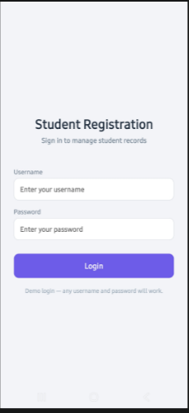
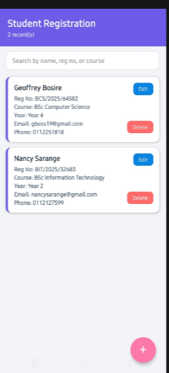
TOOLS USED
React Native, Expo (SDK 54), Expo Router, TypeScript, AsyncStorage, Visual Studio Code, Expo Go, Node.js/npm

PERSONAL REFLECTION
Building this app deepened my understanding of React Native and Expo Router. I implemented full CRUD functionality.Debbuging errors like undefined components and folder structure issues taught me persistence and how to read stack traces methodically.

WEEK5
EXPOUSERAPP
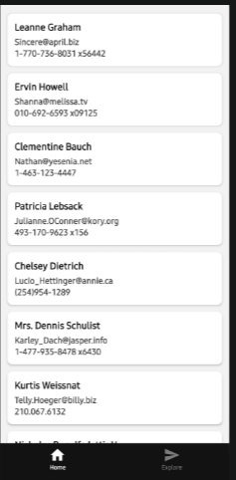
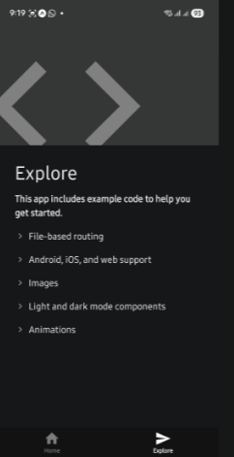
TOOLS USED
Android Studio, Kotlin , Powershell , Node.js , Cardview, Expo Go, VS Code , JSONPlaceholder API

PERSONAL REFLECTION
This project taught me both application development and problem solving, coding with Kotlin and Retrofit the emulator and SDK brought up issues.
Expo and React Native allowed faster progress and successful completion.

WEEK 6
EDUCHECK
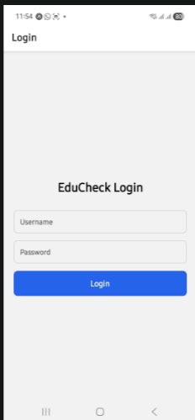
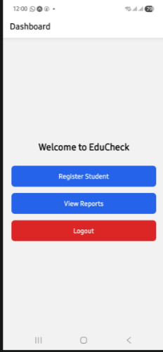
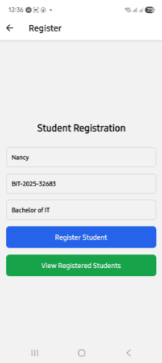
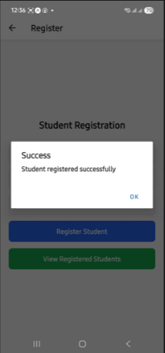
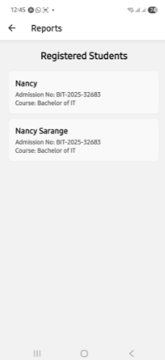
TOOLS USED
React Native (Expo) -cross-platform mobile development framework
Expo Go – for running and testing the application on a physical Android device
@react –navigation/native and @react-navigation/native-stack-screen navigation
Expo-sqlite – local persistent data storage
JSONPlaceholder REST API – sample external data source for networking demonstration
Visual Studio Code – code editor
PERSONAL REFLECTION
The building of this app taught me how navigation, local storage, and APIs work together in real mobile apps.
Debugging file –path was hectic, gained confidence using SQLite for persistence and handling asynchronous API calls. This project deepened my practical understanding of full-stack mobile development concepts learned in class.

